Sure, here are some small scale examples of businesses or organizations uses network maps:

Small businesses:

* A coffee shop: A coffee shop can use a network map to track the flow of orders and payments between their point-of-sale system and their kitchen. This can help to improve efficiency and customer service.

[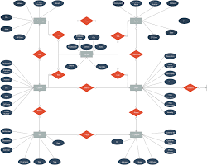Opens in a new window[https://encrypted-tbn3.gstatic.com/favicon-tbn?q=tbn:ANd9GcRTd8WQa6EJTvQBo2OKuNpvprunMQf9bII0EQTIj527cKTKYz7N-5aQKHZwaJzTik056K6yWgaKJJxD3kvcstVVLGe7pkM-](https://creately.com/diagram/example/jfu2alt41/coffee-shop-er-diagram-template-1)creately.com](https://creately.com/diagram/example/jfu2alt41/coffee-shop-er-diagram-template-1)

Coffee shop network map

* A retail store: A retail store can use a network map to track the flow of inventory between their warehouse and their store. This can help to prevent stockouts and ensure that customers can always find the products they are looking for.

[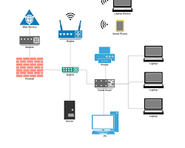Opens in a new window[https://encrypted-tbn1.gstatic.com/favicon-tbn?q=tbn:ANd9GcTAS6CcASKyWwKuUqTv0ZanePAV7jVYZJ_9t16zQumWIVvc_xaWMuGd2TgaVuLJgF-AtUwN9dULBuAlveN23E38T3aqfVaikKa0](https://www.itjones.com/blogs/2020/3/15/how-to-build-a-computer-network-for-your-small-business-part-1-the-basics)www.itjones.com](https://www.itjones.com/blogs/2020/3/15/how-to-build-a-computer-network-for-your-small-business-part-1-the-basics)

Retail store network map

* A medical office: A medical office can use a network map to track the flow of patient data between their electronic health record (EHR) system and their billing system. This can help to ensure that patient data is accurate and up-to-date.

[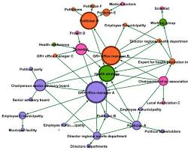Opens in a new window[https://encrypted-tbn1.gstatic.com/favicon-tbn?q=tbn:ANd9GcQ4u2_v7OzUFeU7vUYEBWJIOxVhc9sIyxuUCXXT14jUKDCzsGe3xdCXIP8FcVmZHsdahX_76MhSMKCpmdUh1ol7s04xPUsb](https://www.mdpi.com/1660-4601/18/16/8372)www.mdpi.com](https://www.mdpi.com/1660-4601/18/16/8372)

Medical office network map

Non-profit organizations:

* A soup kitchen: A soup kitchen can use a network map to track the flow of food donations between their suppliers and their volunteers. This can help to ensure that the kitchen always has enough food to serve its clients.

[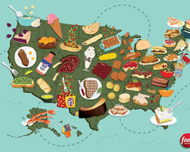Opens in a new window[https://encrypted-tbn3.gstatic.com/favicon-tbn?q=tbn:ANd9GcRdun4SL2JCH-38nyw1GFrSgPgETf3cB3QKza0iTGscrcQkWUy8Op_vwucbFpyH-EjQFctg5e9OPnn6vMgnH7bLX1INs8Ouc2dHyV_68g](https://www.foodnetwork.com/restaurants/packages/best-food-in-america/photos/most-iconic-food-united-states)www.foodnetwork.com](https://www.foodnetwork.com/restaurants/packages/best-food-in-america/photos/most-iconic-food-united-states)

Soup kitchen network map

* An animal shelter: An animal shelter can use a network map to track the flow of animals between their adoption center and their foster homes. This can help to ensure that animals are always placed in safe and loving homes.

[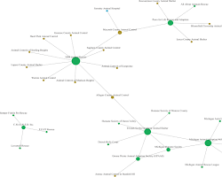Opens in a new window[https://encrypted-tbn3.gstatic.com/favicon-tbn?q=tbn:ANd9GcQ6deI5PZ6m-0EHDBxmN78j3Egj2RC3QbExU6wgReEi-PUHqjDix8dHIXxEi84B-0FBTx_od06-XPtsF0pFoDzYvuTUEj8KXCm77D3tXfE](https://journals.sagepub.com/doi/full/10.1177/0160323X211009285)journals.sagepub.com](https://journals.sagepub.com/doi/full/10.1177/0160323X211009285)

Animal shelter network map

* A community center: A community center can use a network map to track the flow of resources between their programs and their clients. This can help to ensure that clients are always able to access the resources they need.

[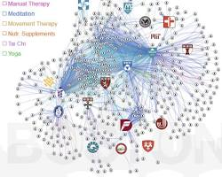Opens in a new window[https://encrypted-tbn2.gstatic.com/favicon-tbn?q=tbn:ANd9GcRWfkGU8gFNEHbtwn6sXksRI7cB5YdqQmOgpKLT6FIGx57BE-FJLMR_vIZvYr73HgiIvTtukgGWo0lVNSf8rltqdrRxaHSttNtwNLdqSoVIQBdst80](https://www.oshercollaborative.org/highlight/local-community-research-networks)www.oshercollaborative.org](https://www.oshercollaborative.org/highlight/local-community-research-networks)

Community center network map

tuneshare

more_vert

add_photo_alternate